# Chinook Music

User Manual

David MacDonald

Student: B00394201

Index Page: Home Menu. Click on any button to navigate to that menu.

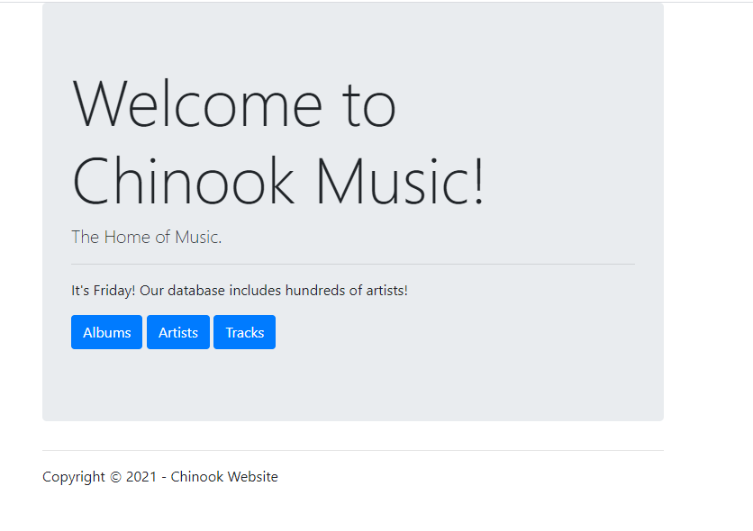

Artists Page: From here an employee can Create new Artists, edit, and delete current artists.

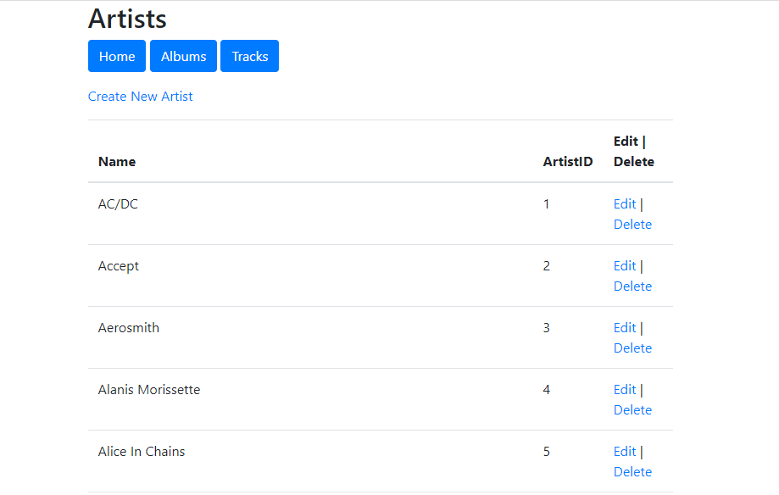

Edit Artist Page: An employee can edit current Artists or cancel the changes made.

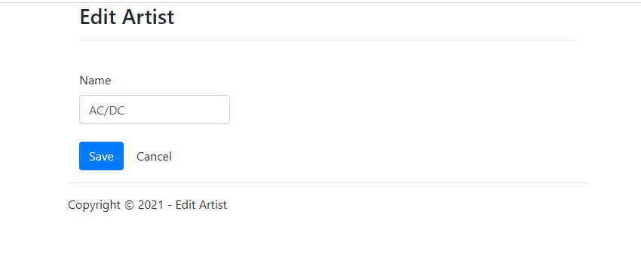

Warning message upon delete selection.

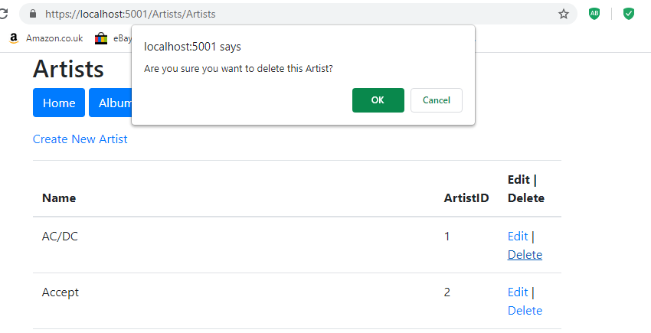

Create Artist Page. An employee can enter an artist’s name and that name will be added to the database with an auto incremented Artist ID number.

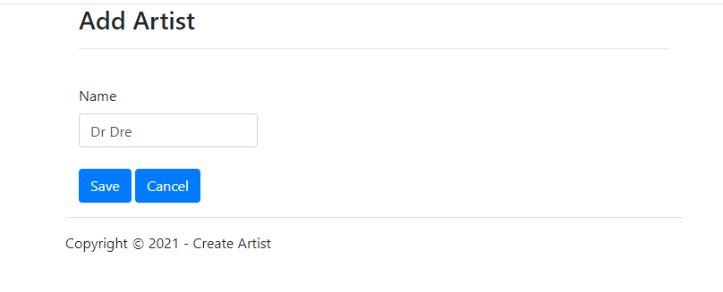

Below we can see the artist has been added with the ID of 289.

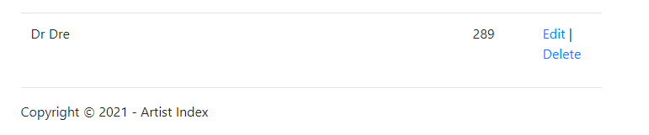

Album Page. An employee can view the entire list of albums with the artist associated with them. From here an employee can create a new album, edit, and delete current albums or view the details of current albums.

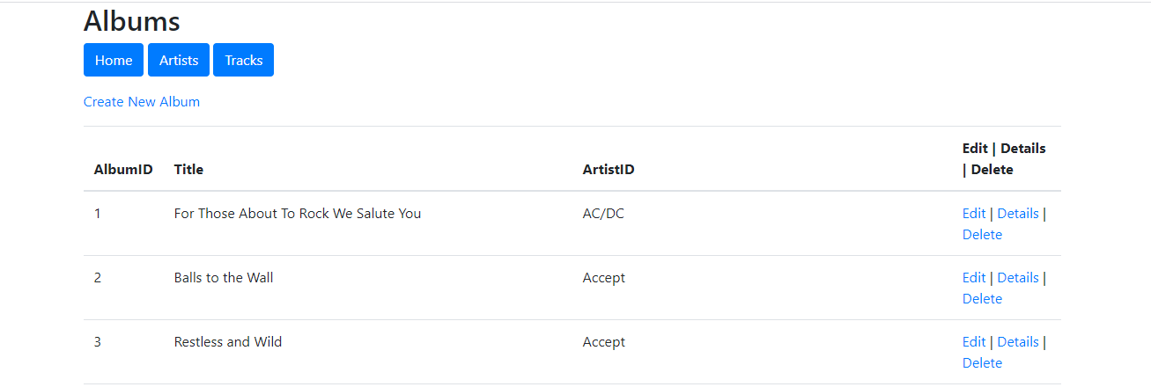

Create New Album Page. An employee can add a new album by typing the album name and selecting an artist from the drop-down menu. If the artist is not there, then the employee can click “Create New Artist” This will take them to the create Artist page.

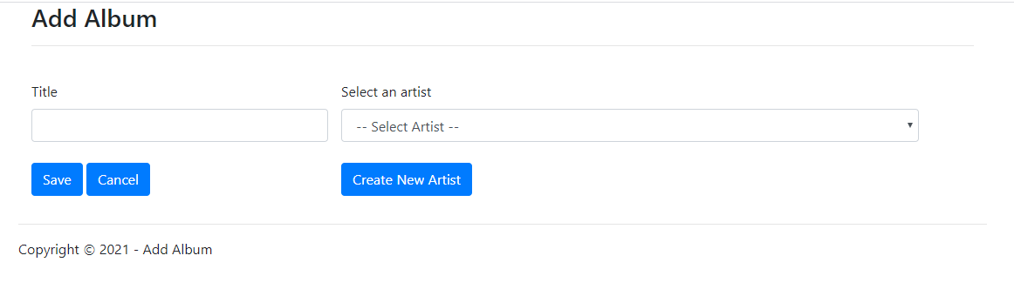

Below is an example of a newly created an album with the previously created artists. Edit, Details and Delete are now available for that album.

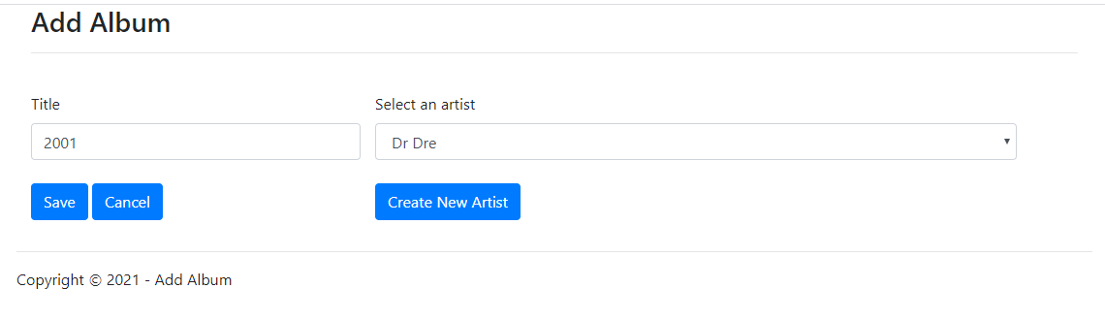

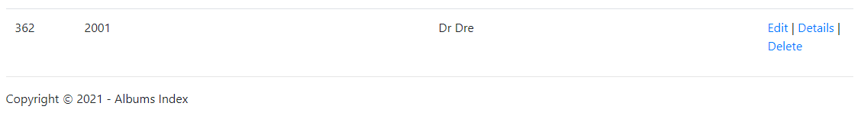

Below are the details of that album. There are no tracks created as of yet and this can be done by selecting the Create Track button. An employee can also edit the album or view the artist info.

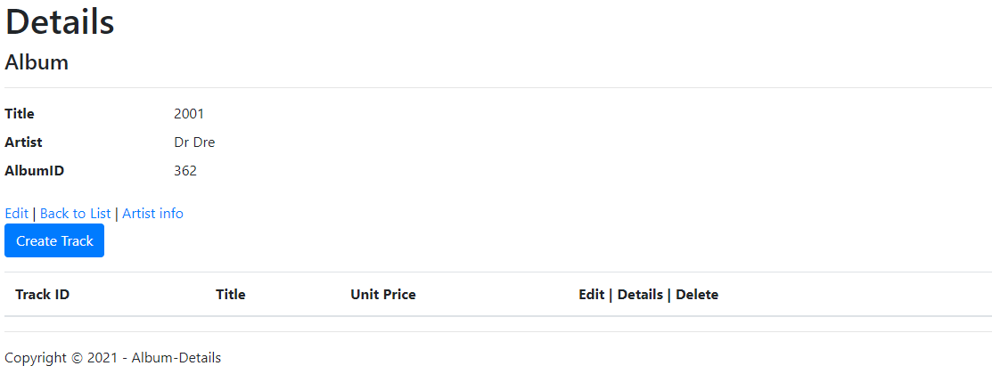

Artist Details:

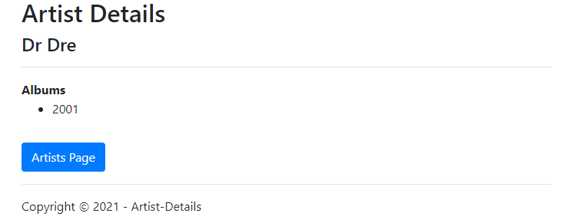

Track being added:

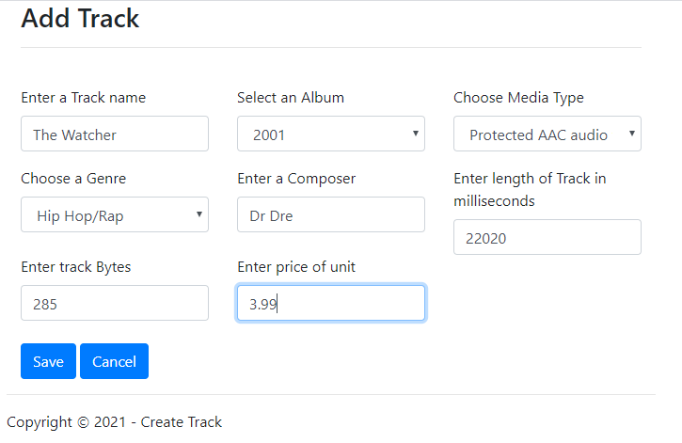

The track is now displayed in the album details. Where it can be deleted, edited, and the details can be displayed.

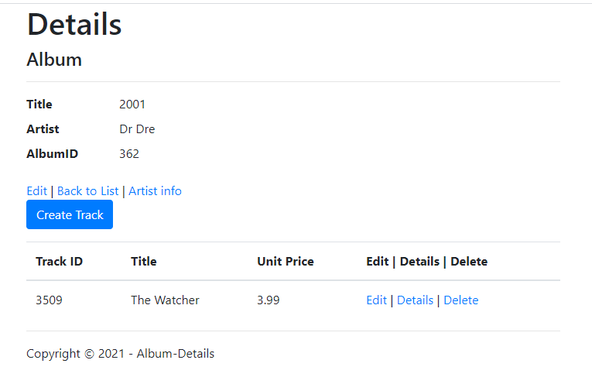

Edit Track details:

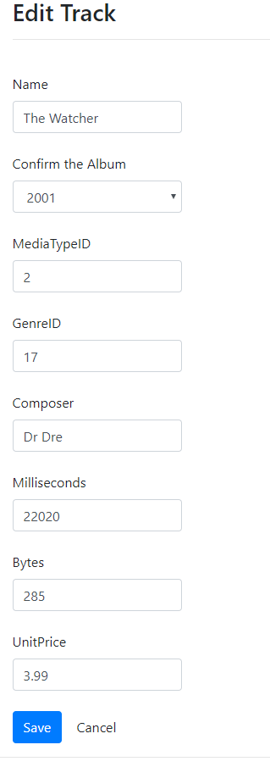

Tracks Page. Displays a full list off all the tracks in the database where an employee can edit, delete or view track details.

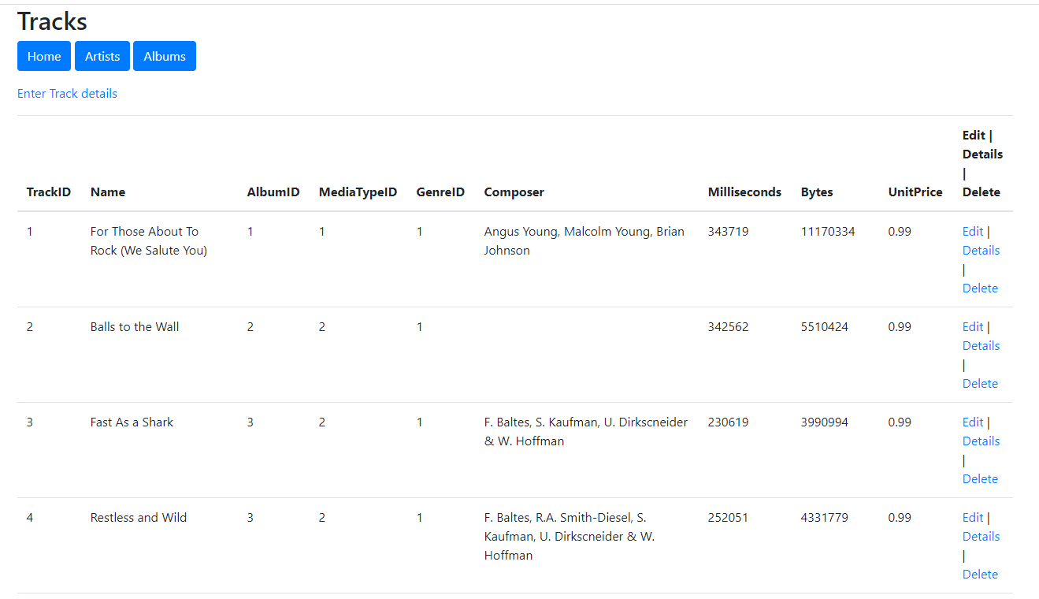

Delete Artist. A confirmation message appears to make sure nothing is deleted by accident.

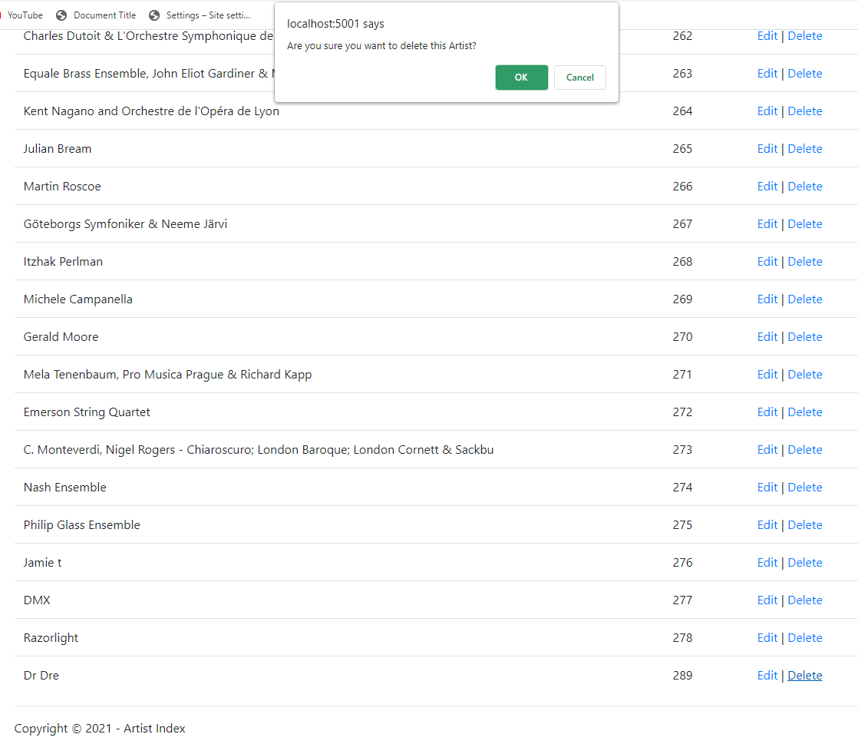

Artist has now been deleted from the database.

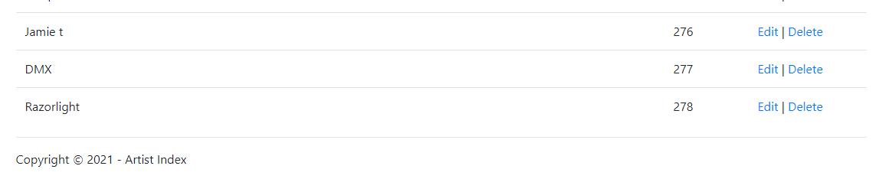

The artists album has also been deleted from the database.

